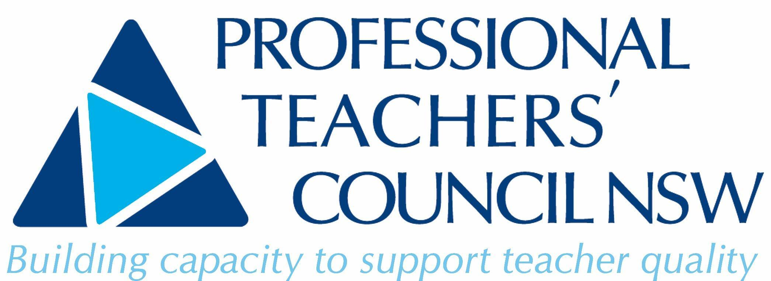

Notice of

2022

Annual General Meeting

Professional Teachers’ Council NSW

Saturday 29th October 2022

9.45am for 10.00m

Via Zoom

